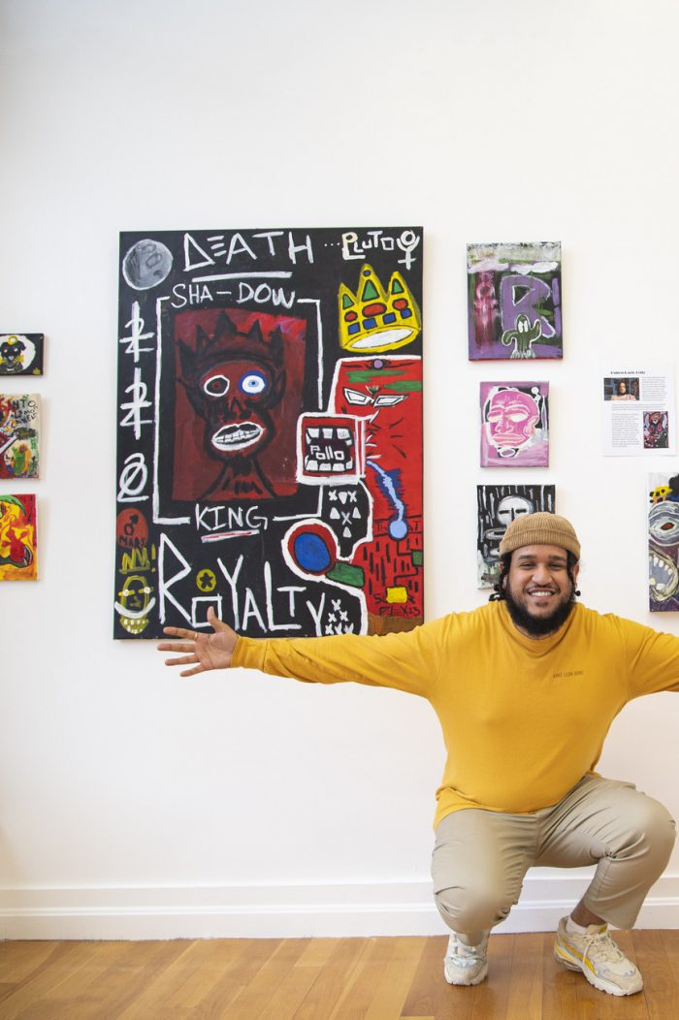
Ruben Dario Feliz stands next to his mixed media canvas paintings inside the LynnArts gallery space. (Jakob Menendez )

Black history on display at LynnArts
By Sophie Yarin | February 9, 2022
LYNN — Black History Month is about a lot of things.
Advocacy, justice, healing, education, and aspiration are just a few of the principles that scaffold the month-long celebration, but Galleries at LynnArts (GALA) has its eye on one of the most important principles of all ― imagination.
This month, GALA's acknowledgement of the Black community takes the form of "Past and Present: Black Art and Artists," an exhibition that highlights the artwork of local members of the African diaspora.
"The mission of GALA is making (it) a place that is comfortable and inviting for people in our community who have been disenfranchised previously," said Annette Sykes, GALA president and gallery director. "A 'white box' concept gallery is not a comfortable place for many of the BIPOC (Black, Indigenous people of color) artists to walk into, or visitors to walk into, and I think by seeing portraits hanging in the window that look like you, it'll make the space seem more approachable, more inviting."
With a focus on equity, Sykes was invested in bringing in as much community input as possible. A conversation with Michelle Guzman, community organizer and founder of Lynn Walking Shoe Tours, pointed Sykes in the direction of Nicole McClain.
McClain is the founder of North Shore Juneteenth Association, which has been responsible for numerous community-oriented initiatives aimed at uplifting Black voices around Massachusetts.
"Michelle said 'Why don't you approach Nicole to collaborate on a show?' and it was just such a silly, 'well gee, why didn't I think of that?' moment," Sykes recalled. "When I called Nicole in November, she immediately agreed, and we started working on it in January."
McClain's enthusiasm matched Sykes'. In an interview, she said she had always wanted to mount an art exhibition with a focus on Black artists. But McClain, who chairs the exhibition, had other elements in mind; as soon as she became involved, the nature of the show began to transform.
"I suggested that we highlight the local Black American artists, or artists from the diaspora, that identify with the African-American side of their culture, (and) mix that with historical artists that are of the African diaspora as a whole and let them bring that to the table about who influenced them," she said.
The resulting show, "Past and Present," is a four-week exhibition of four Black artists, with each artist getting a feature week for their work and the work of a historical Black artist of their choosing.
"I feel like a lot of people don't know that these people are actually here and that they're working in our community," McClain said of the four local artists. "I would love to bring awareness to them and have our community recognize them and also educate (the public) and hopefully spark their desire to learn more about historical Black artists and historical Black stories."
All four featured artists were known to McClain or Sykes through GALA, or simply their presence in the community. As for the first featured artist, Wendy Ekolé (@thesophisticatedchaton), her friendship with Sykes goes back to when the two women taught together at Lynn Vocational Technical Institute.
"We're just good friends," Sykes said, who added that the Lynn Tech math teacher began painting more seriously during the COVID-19 pandemic.
"We spent lots of time talking on the phone when nobody could see each other and it was a real support… She has a style that is just so playful, and it's raw talent," Sykes added.
After Ekolé, Ruben D. Feliz (@rubendfeliz) will feature his work. The artist's style was described by Sykes as reminiscent of iconic Neo-Expressionist Jean-Michel Basquiat, whom Feliz chose as his historical Black artist.
"He's been on my radar for a while," Sykes said. "He has a couple of pieces in the main gallery right now which are very experimental and I'm excited about what comes next for him."
Following Feliz is young artistic standout Jah'Nyah Spencer (@_jah.nyah_) who, after graduating from Lynn Tech in 2021, has cemented herself in the Lynn art scene. The Lesley University Class of 2025 student has been involved with organizations like Raw Art Works and Beyond Walls, where she contributed art to the "Truth Be Told" mural project in 2020. In 2021, Spencer was one of the local artists chosen to collaborate on a "Black Lives Matter" mural in downtown Lynn.
"For my inspiration, I looked online at pictures of beautiful Black women,” Spencer told the Boston Globe in 2020. “With everything going on in the world, with justice not being served for people of color, I thought people needed to see that Black is beautiful and that we, too, deserve to be heard.”
The show will close with Ellery Sanchez (@mismoestrella), the only photographer featured in the exhibition. Sanchez' work has also been featured in past GALA shows, and his inclusion in "Past and Present" was proposed by Ekolé, according to McClain.
"He totally fit in with the show," Sykes said of Sanchez. "And it was really important in my eyes to have a photographer in this show."
Sykes could not overemphasize the important role that artist exposure plays in "Past and Present." GALA's mission, she affirmed, was to uplift artists from all disciplines and all walks of life.
"In some circles in the art world, (the) letters associated with your name mean something and, in other ways, it's the work that you put in at the easel or behind the camera ― and that's what these artists do," she said. "We're living in a time where that canon, that art-history book, is being torn open, and that's been happening for quite a while now. We haven't gone as far as we could, but this is the tip of the iceberg, and this is local. I'm hoping that this can be a first stepping stone."
"Past and Present: Black Art and Artists" will be on display at GALA from Friday, Feb. 11 to Monday, March 14. The dates for each artists' feature weeks are as follows: Wendy Ekolé from Feb. 15-21, Ruben D. Feliz from Feb. 22-28, Jah'Nyah Spencer from March 1-7, and Ellery Sanchez from March 8-14. More information about GALA can be found at https://www.galleriesatlynnarts.org and @galleriesatlynnarts.
McClain, too, was eager to see what effect "Past and Present" would have on the future.
"I'm so happy that it's all coming together and going to happen ― it's happening," she said. "The community is going to learn about them."

